**Project 3: On the Road**

Movement, music, direction, and dance: *a situation based on psychogeography; a dérive*

### Due Date

Submitted and Critiqued: 4:00 pm, Monday 01 April 2024  
Due to the outdoor nature of this project, *there can be no late submissions.*

Late submissions will result in 0%.

### The Question

*What is a place and who are we inside of it?*

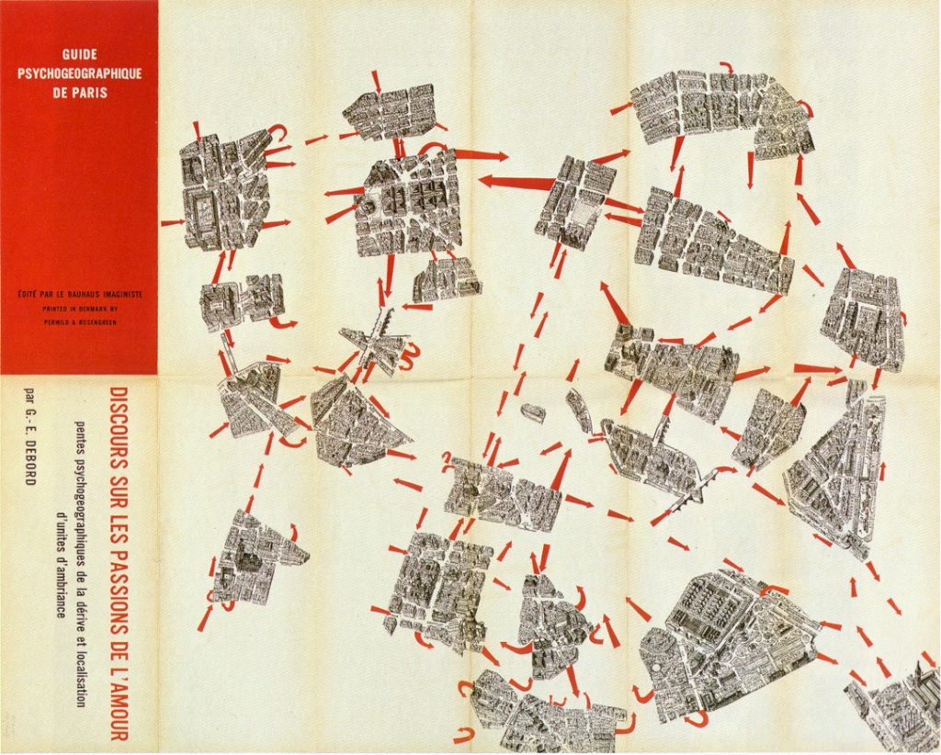

***(Psychogeography Guide by the Situationists International)***

### Initial Research

Charge up your phone and bring your batteries - *we’re all going outside.*

Alone or with a partner ([enter yourself or your group on this spreadsheet](https://docs.google.com/document/d/1J_BywQXJyUM16VwJ6iYtuRSH3QJX9yb5-8iqvqxjbow/edit?usp=sharing)), go on a walk around campus: anywhere you’d like, and maybe some places you wouldn’t.

Avoid having a destination in mind. Develop a simple game that dictates where you go (e.g. if there’s a tree, go straight; if there’s a brick building, go inside it and take the elevator wherever the next person who enters goes; if someone in a blue shirt walks in front of you, sit at the next bench you see and people watch for 5 minutes, etc). Sketch, write, take photos of your experience. What you see, what you hear, what you smell, how things feel.

Where did you end up? What is around you? Do you know anything about this place? What did it used to look like? Have you ever noticed it before?

Research the [Situationists International](https://en.wikipedia.org/wiki/Situationist_International), [Guy Debord](https://en.wikipedia.org/wiki/Guy_Debord), and the concept of the [dérive](https://en.wikipedia.org/wiki/D%C3%A9rive) (*drifting*). Research, read, watch, and talk about the history of UIC’s campus, it’s architecture, the [former neighborhood that was demolished](https://www.chicagohistory.org/origins-of-university-of-illinois-chicago/) to build the [Walter Netsch](https://en.wikipedia.org/wiki/Walter_Netsch) campus, and the extensive [demolition and reconstruction of east campus](https://collections.carli.illinois.edu/digital/collection/uic_fac/id/2689/) over the last 25 years. Maybe visit the [James Turrell light pavilion](https://cada.uic.edu/schedule/james-turrell-in-light/) (famous installation and architectural artist) and wonder why it exists.

Some resources to get you *started*:

* [The Situationist International 1957-1972 / Branka Bogdanov / 1989 (youtube.com)](https://www.youtube.com/watch?v=eBlSBI64UxY&ab_channel=COUNTERPUBLICS)
* [The Dérive: An Introduction (youtube.com)](https://www.youtube.com/watch?v=CbY9T5C8Pf8&ab_channel=NikkiAndrews)
* [Psychogeography- The Art of Getting Lost (youtube.com)](https://www.youtube.com/watch?v=ujbCJFjqqmw&ab_channel=YzsnjoyPerez)
* [Derive 'urban exploration app' (youtube.com)](https://www.youtube.com/watch?v=4kTukct98vA&ab_channel=deriveapp)
* History of Greek Town Neighborhood: [University of Illinois at Chicago (chicagohistory.org)](http://www.encyclopedia.chicagohistory.org/pages/1290.html)
* History of Campus and Development: [University of Illinois Chicago (uic.edu)](https://www.uic.edu/about/history/)
* History of Campus Architecture: [The Netsch Campus: Exploring the Evolution of UIC's Architecture (youtube.com)](https://www.youtube.com/watch?v=9rIc3jllhFE&ab_channel=UICAlumniAssociation)

### The Assignment (Full Description)

Once you have finished your research, use all of the following tools to craft an outdoor dérive based on p5/javascript for the class to go on:

* phone cameras and microphone input
* image and [sound classification](https://www.youtube.com/watch?v=cO4UP2dX944&ab_channel=TheCodingTrain) (speech or sound recognition) with ml5.js (to recognize places, people, poses, etc) - you will need to take many photos and record many audio clips of campus to train multiple classes of your model with Teachable Machine
* sound synthesis or playback with the p5 sound library
* visuals (images, shapes, text, etc) that complement the dérive
* should last about 10 minutes

Create a system of rules that guide us on a unique dérive based on what we see (with our camera) and what we hear (with our microphone).

Perhaps, if we see University Hall then play a sound, a song, or a poem that shares something (historical or poetic, personal or general) about that place; or directly show us a series of instructions to do next (go inside and say hello to the first person we encounter, take the elevator as far as you can go to the top then ask someone for directions to the bottom); or tell us to make a specific drawing and show it to our camera, giving us new instructions afterward. Maybe ask us to choose how we feel about that place, or if we’d like to destroy it and build something new (or not). Consider how the rules might change if the dérive is being carried out alone or in a group.

The places, spaces, sounds, and actions that dictate the rules are *up to you*, but you should use a variety of rules and conditions and lead us through space in an unexpected way for about 10 minutes. There can be an official ‘ending’ to the dérive based on any conditions you like, or you can leave things open.

You may start us off with instructions for some things to try and find, sounds to listen for (or something else just to get us going). Do *not* have us start in a specific place.

In your sketch add images, shapes, and other overlays to build a story for us as we move through the world - but focus primarily on *what we see and what we hear* - those are the most important things.

*Critically, our experience should not be linear* (one place, to another, to another, in a planned way). What we see first that is recognized using the image/sound classifier should be used to create a *condition* that then directs us to the next goal (heading to a place, doing an action, singing a song, etc). [Consider the humble text-based adventure game](https://www.youtube.com/watch?v=PWQDccL0aXM&ab_channel=GameHorder) as a product of dérive. Consider mapping your rules out in a decision tree or flow chart.

***Do not be shy or afraid to ask us to do something strange or uncomfortable*** (of course nothing illegal, please). This is a university campus - and these dérives are our experiments and research.

### Requirements and Rubric

* (30%) Original Content:
* (30%) Demonstrates Technical Understanding and uses all required tools
* (40%) Must be ready to experience (outside, as a class) on 01 April 2024 during our critique times (we will take two days for these critiques). Due to the outdoor nature of this project, being unable to present without an official, documented excuse will result in 0%. There will be no late submissions for this project.

### Submission Guidelines

Link to Sketch must be submitted to the [Project 3 Submission Spreadsheet](https://docs.google.com/document/d/1ew7gpuCTVvejsEdcGNUtSGW_X3vJ1HYrr8vtBBOQXWo/edit?usp=sharing) no later than 4:00 pm, 01 April 2024. You must contact me about submission concerns or questions no later than 5:00 pm, 31 March 2024.

We will all follow each derive individually (or in small 2-3 person self-selected groups) and in any submission order. Feedback will be in the second half of class on submission days.

Refer to the Syllabus for Late Submission Guidelines.